9 March 2007 The Weekly Bulletin of Rotary Club of Kathmandu Mid-Town Bc # 36 of 2006-07
Rotary Club of Kathmandu Mid-Town
Breakfast Chatter




District : 3290 Web: www.rotarymidtown.org.np Club Id : 26776

MARCH IS WORLD ROTARACT (WEEK) MONTH
Rotary clubs which sponsor Rotaract clubs are encouraged to invite Rotaractors on at least a quarterly basis to their regularly scheduled meetings, project planning meetings, and special events, and are encouraged to review Rotary club membership potential within their Rotaract clubs on a periodic basis.

Guest Speaker Mr Jan S Roukema talked about his food for thought : African experience
at the Club meeting on 2 March 2007.
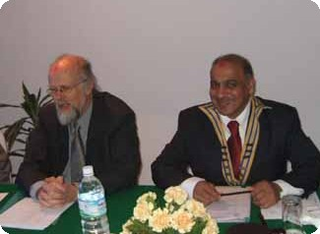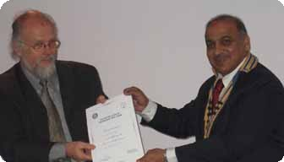
a) Guest Speaker Jan presenting his food for thought while President CK Golchha looks on;
b) Mr Roukema receiving a Certificate of Appreciation from President CK;
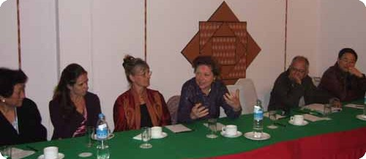
c) Rtn Dr Isabella participating in interaction d) while Speaker Roukema listening to.

Weekly Meetings and Programs :
Date | Program/Speaker | Program/Topics of Presentation
9 March 2007 | Dr Susanne von der Heide | Kathmandu Valley, then and now: Safeguarding campaign of Unesco
16 March 2007 | Joseph/Brigitte Cazalis-Collins | One couple's experiences and reflections while working on projects in Nepal.
23 March 2007 | Rtr Prashanna Shrestha, | Joint meeting with Rotaract Club of KMT
30 March 2007 | Dinner meeting | Dinner meeting

Friday, 9 March :
Dr Susanne von der Heide is the Director of the HimalAsia Foundation since 2001, which is operating in the Himalayan Areas, South and Central Asia. The main aim of the HimalAsia Foundation is to safeguard culture and nature by motivating and including the participation of local people. The Foundation is supported by different Organisations like UNESCO or BMZ (German Ministry for Economical Exchange). She will be talking at the Rotary meeting on "the Kathmandu Valley Then and Now" and UNESCO International Campaign for safeguarding the cultural heritage of the Kathmandu Valley.

U-turn in tourism business :
Asia's fastest growing economy's potential can be so far-reaching that even if less than one percent of China's total outbound tourists visited Nepal annualy, the tourism industry would take a U-turn provided the "Land of the Buddha" can produce requisite facilities. Nepal's casinos and world heritage sites can help lure the burgeoning neo-riche tourists next door.
In 2006, Nepal received only 8,000 Chinese tourists. The absence of a Nepali diplomatic office in the trading hub of Guangzhou is reportedly hindering the inflow of tourists and businessmen from the northern neighbour. To obtain a visa, they have to either visit the Nepali consulate in Hong Kong or Shanghai or travel all the way to Beijing that unnecessarily adds up to the overheads. The arrivals could shoot up by two to three fold by just establishing a diplomatic office in Guangzhou. If not a consulate, at least, an honourary consul or some officials from Hong Kong or Shanghai could be deputed for visa facilitation. The China Southern Airlines can fullfill its target of bringing in 10,000 tourists this year with a well-thought-out promotion drive. But prior to that, the imperatives of infrastructural development and upgradation of facilities like transportation, hotels and restaurants, etc, will have to be completed. Training more guides and publishing advertisemnts in Chinese language could be more effective. With the adoption of a practical, realistic and business-like strategy, the required U-turn wouldn't be a big deal.
Source: The Himalayan Times

On Lighter Side : Click at the figure ⇩

Programs like Interact, Rotaract, and Rotary Youth Leadership Awards (RYLA) have tremendous value, not only to their participants, but to the future of Rotary. By introducing volunteer service at an early age, these clubs teach the lifelong lessons of Rotary: the satisfaction that comes from helping others and the fun of good work with good friends.
RI President William B. Boyd

9 March 2007 The Weekly Bulletin of Rotary Club of Kathmandu Mid-Town Bc # 36 of 2006-07

Editor: RR Shrestha, Club Service Director email: rryes@wlink.com.np

